Name: Eman Khurram

SapID: 63725

Department: Bs-Cyber Security

Lab Task: 1

Task 1:

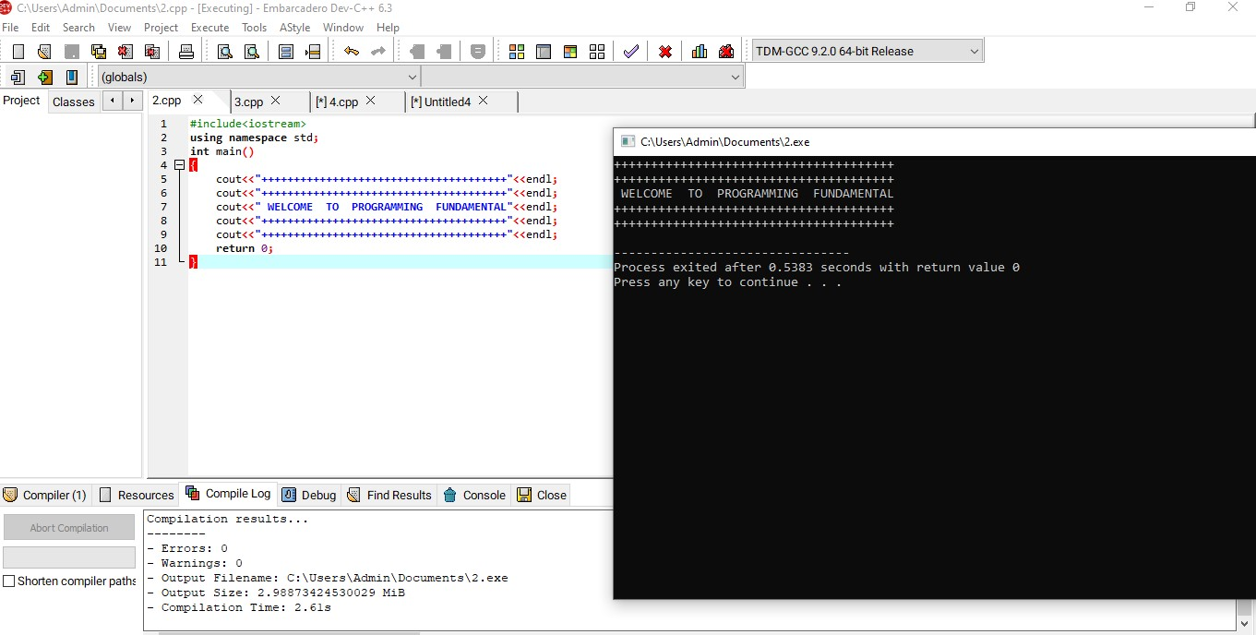

Task 2:

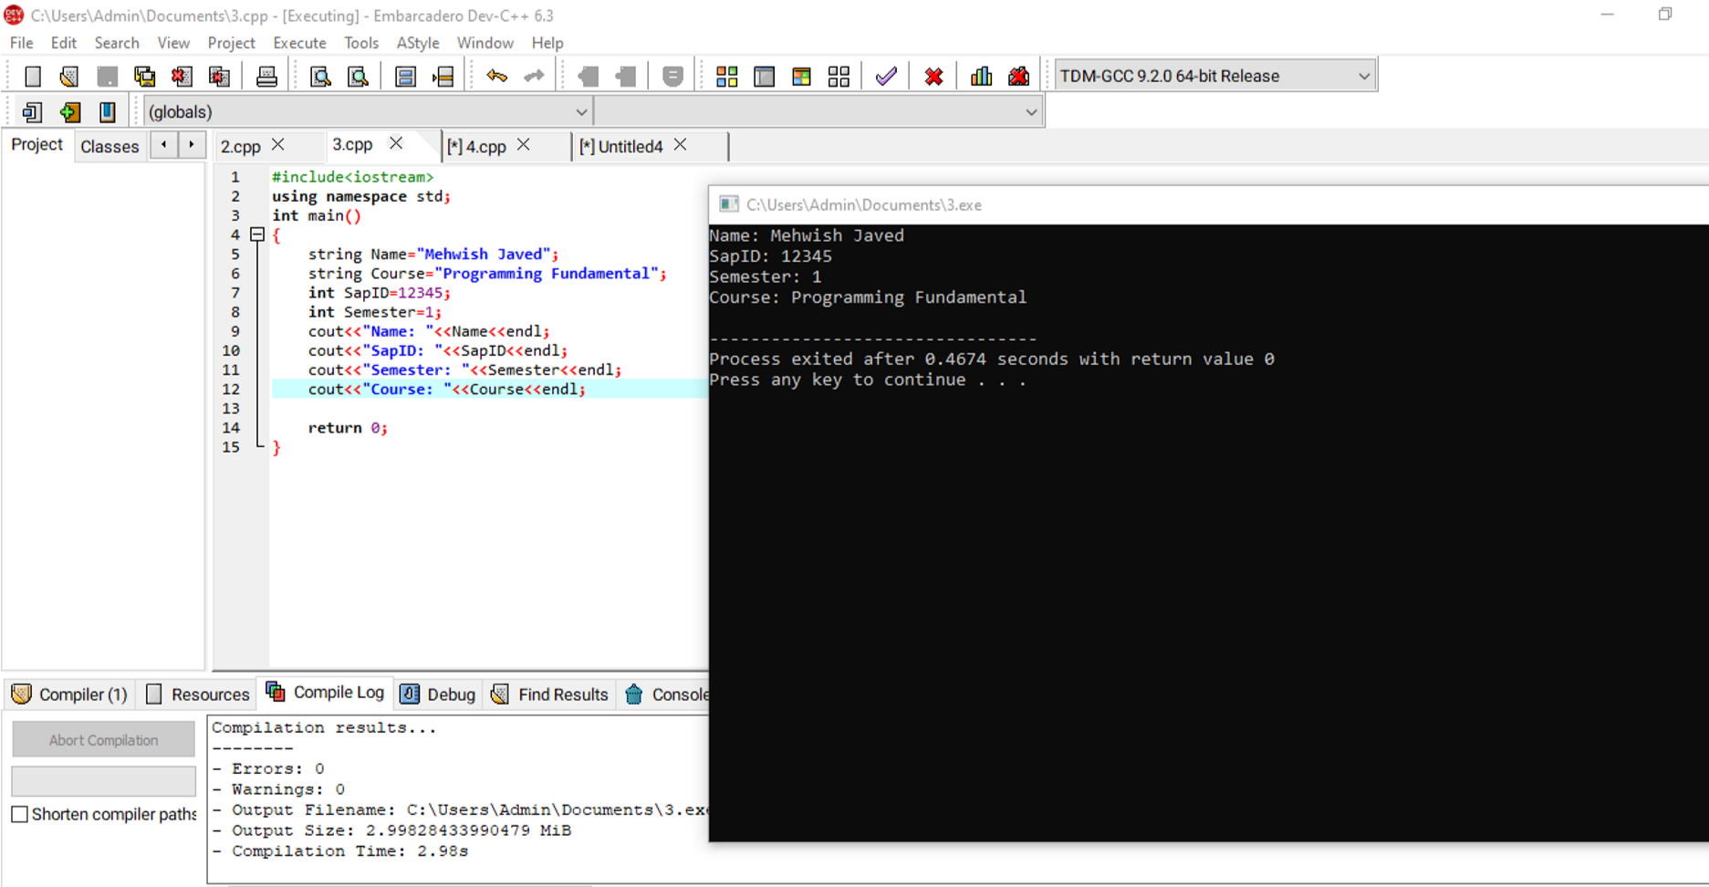

Task 3:

